DNS SOA Record

🏁 What is a DNS SOA Record?
# Source: AI Source: Provided by: [Data Path: Persons Table -> ID Column: 1, Name_En Column: Motasem Essam] -> From: [ChatGPT] on [1/18/2026]
An SOA Record (Start of Authority) is a crucial DNS record that provides important information about a DNS zone, including the primary authoritative name server for the domain and various control parameters.
🧠 Think of the SOA record as the official “start” of a DNS zone file, containing metadata about the domain’s DNS settings.

🔍 Key Components of an SOA Record
# Source: AI Source: Provided by: [Data Path: Persons Table -> ID Column: 1, Name_En Column: Motasem Essam] -> From: [ChatGPT] on [1/18/2026]
An SOA record includes:
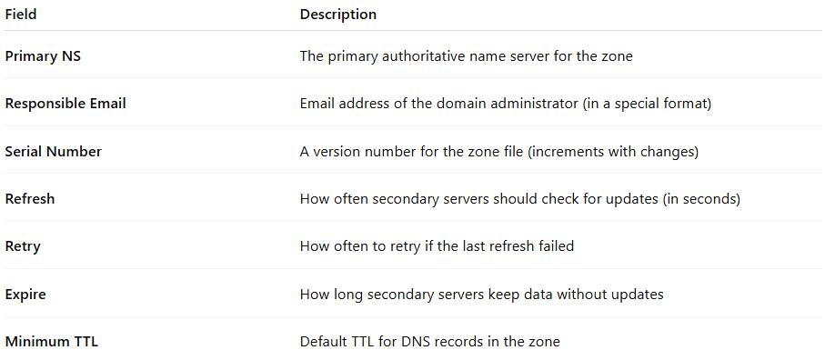

Field | Description
Primary NS | The primary authoritative name server for the zone
Responsible Email | Email address of the domain administrator (in a special format)
Serial Number | A version number for the zone file (increments with changes)
Refresh | How often secondary servers should check for updates (in seconds)
Retry | How often to retry if the last refresh failed
Expire | How long secondary servers keep data without updates
Minimum TTL | Default TTL for DNS records in the zone

🔧 Example SOA Record
# Source: AI Source: Provided by: [Data Path: Persons Table -> ID Column: 1, Name_En Column: Motasem Essam] -> From: [ChatGPT] on [1/18/2026]
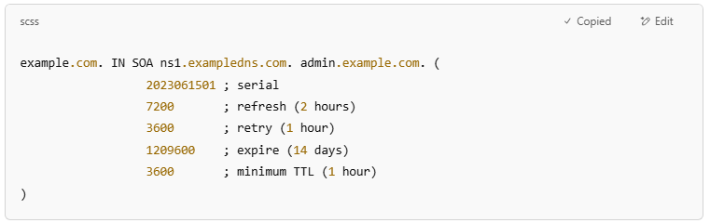
example.com. IN SOA ns1.exampledns.com. admin.example.com. (
2023061501 ; serial
7200 ; refresh (2 hours)
3600 ; retry (1 hour)
1209600 ; expire (14 days)
3600 ; minimum TTL (1 hour)
)

🌐 Why is the SOA Record Important?
# Source: AI Source: Provided by: [Data Path: Persons Table -> ID Column: 1, Name_En Column: Motasem Essam] -> From: [ChatGPT] on [1/18/2026]
- It controls zone transfers between primary and secondary DNS servers.
- Helps DNS servers know when to update cached info.
- Identifies the authoritative source and admin contact for the DNS zone.

✅ Summary
# Source: AI Source: Provided by: [Data Path: Persons Table -> ID Column: 1, Name_En Column: Motasem Essam] -> From: [ChatGPT] on [1/18/2026]
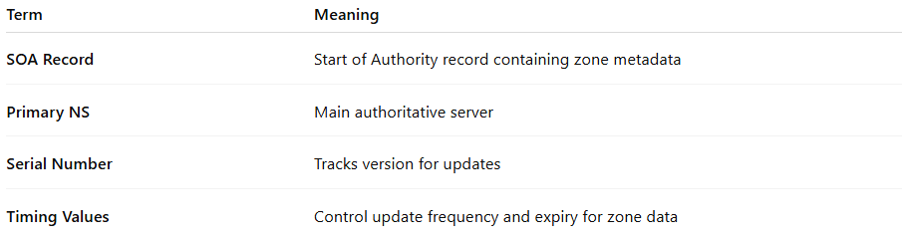
Term | Meaning
SOA Record | Start of Authority record containing zone metadata
Primary NS | Main authoritative server
Serial Number | Tracks version for updates
Timing Values | Control update frequency and expiry for zone data

